A picture containing clipart

Description generated with very high confidence

Python Core Project

[**support@intellipaat.com**](mailto:support@intellipaat.com)

**+91-7022374614**

**US: 1-800-216-8930(Toll Free)**

**Python Certification Project**

**Project:** Build a Hangman Game

**Industry:** General

**Problem Statement:**

You have been asked to build a hangman game in command prompt using python

**Description:** In this project we will use python to build the hangman game, in the game you have are given 9 guesses and you are allowed 3 hints. You have to guess a word by making a guess of each character one by one. For example, if the word in PYTHON and you first guess is P then the game will show you that your guess was correct and the position of the word where P exists in the game.

The output should look like this:

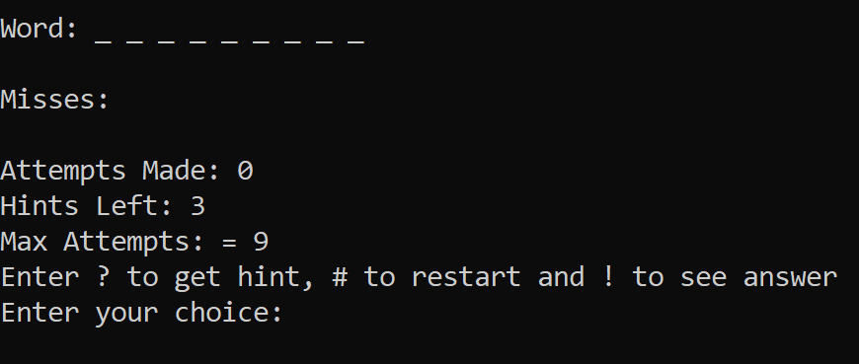

**Tasks to be performed**:

* The first screen should display option to either start the game or exit
* After starting the game user should have Max Attempts 9 and Max Hints 3
* If user asks for a hint, you have to reduce hints left by one and then show one of the letters and its position in the word
* Allow user to get hint by giving ‘?’ as choice, to restart ‘#’ as choice and to see the answer ‘!’ as choice
* If user wins display a congratulatory message on screen
* If user loses go back to main menu from where user can start the game again
* User should be able to enter the choice in the prompt
* Try to make your code easy to read and reusable using object oriented programming i.e. classes and objects
* NOTE: There are several ways to implement the solution. Just make sure you check for equality and ignore casing i.e. ‘P’ is equal to ‘p’